**Hands on 1**

**Create a Spring Web Project using Maven**

**Follow steps below to create a project:**

Go to https://start.spring.io/

Change Group as “com.cognizant”

Change Artifact Id as “spring-learn”

Select Spring Boot DevTools and Spring Web

Create and download the project as zip

Extract the zip in root folder to Eclipse Workspace

Build the project using ‘mvn clean package -Dhttp.proxyHost=proxy.cognizant.com -Dhttp.proxyPort=6050 -Dhttps.proxyHost=proxy.cognizant.com -Dhttps.proxyPort=6050 -Dhttp.proxyUser=123456’ command in command line

Import the project in Eclipse "File > Import > Maven > Existing Maven Projects > Click Browse and select extracted folder > Finish"

Include logs to verify if main() method of SpringLearnApplication.

Run the SpringLearnApplication class.

SME to walk through the following aspects related to the project created:

src/main/java - Folder with application code

src/main/resources - Folder for application configuration

src/test/java - Folder with code for testing the application

SpringLearnApplication.java - Walkthrough the main() method.

Purpose of @SpringBootApplication annotation

pom.xml

Walkthrough all the configuration defined in XML file

Open 'Dependency Hierarchy' and show the dependency tree.

**Answer:**

**pom.xml**

<project xmlns="http://maven.apache.org/POM/4.0.0"

xmlns:xsi="http://www.w3.org/2001/XMLSchema-instance"

xsi:schemaLocation="http://maven.apache.org/POM/4.0.0 https://maven.apache.org/xsd/maven-4.0.0.xsd">

<modelVersion>4.0.0</modelVersion>

<parent>

<groupId>org.springframework.boot</groupId>

<artifactId>spring-boot-starter-parent</artifactId>

<version>3.1.1</version> <!-- or your preferred version -->

</parent>

<groupId>com.cognizant</groupId>

<artifactId>spring-learn</artifactId>

<version>0.0.1-SNAPSHOT</version>

<name>spring-learn</name>

<description>Demo Spring Boot Web Project</description>

<properties>

<java.version>17</java.version>

</properties>

<dependencies>

<!-- Spring Web -->

<dependency>

<groupId>org.springframework.boot</groupId>

<artifactId>spring-boot-starter-web</artifactId>

</dependency>

<!-- Optional: For live reload -->

<dependency>

<groupId>org.springframework.boot</groupId>

<artifactId>spring-boot-devtools</artifactId>

<scope>runtime</scope>

<optional>true</optional>

</dependency>

<!-- For testing -->

<dependency>

<groupId>org.springframework.boot</groupId>

<artifactId>spring-boot-starter-test</artifactId>

<scope>test</scope>

</dependency>

</dependencies>

<build>

<plugins>

<plugin>

<groupId>org.springframework.boot</groupId>

<artifactId>spring-boot-maven-plugin</artifactId>

</plugin>

</plugins>

</build>

</project>

**SpringLearnApplication.java**

package com.cognizant.spring_learn;

import org.springframework.boot.SpringApplication;

import org.springframework.boot.autoconfigure.SpringBootApplication;

@SpringBootApplication

public class SpringLearnApplication {

public static void main(String[] args) {

SpringApplication.run(SpringLearnApplication.class, args);

}

}

**Country.java**

package com.cognizant.spring_learn.model;

public class Country {

private String code;

private String name;

public Country() {}

public Country(String code, String name) {

this.code = code;

this.name = name;

}

public String getCode() {

return code;

}

public void setCode(String code) {

this.code = code;

}

public String getName() {

return name;

}

public void setName(String name) {

this.name = name;

}

}

**CountryController.java**

package com.cognizant.spring_learn.controller;

import com.cognizant.spring_learn.model.Country;

import org.springframework.web.bind.annotation.GetMapping;

import org.springframework.web.bind.annotation.RestController;

@RestController

public class CountryController {

@GetMapping("/country")

public Country getCountry() {

return new Country("IN", "India");

}

}

**Output:**

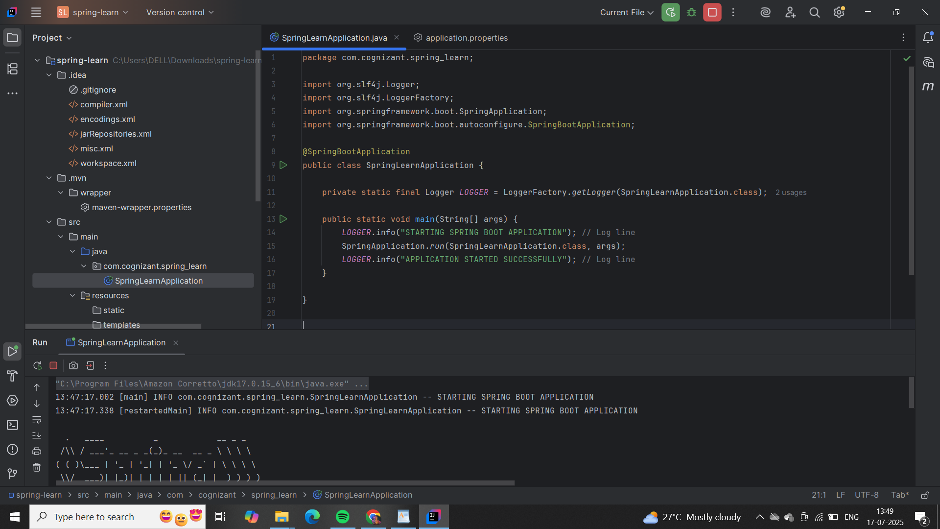

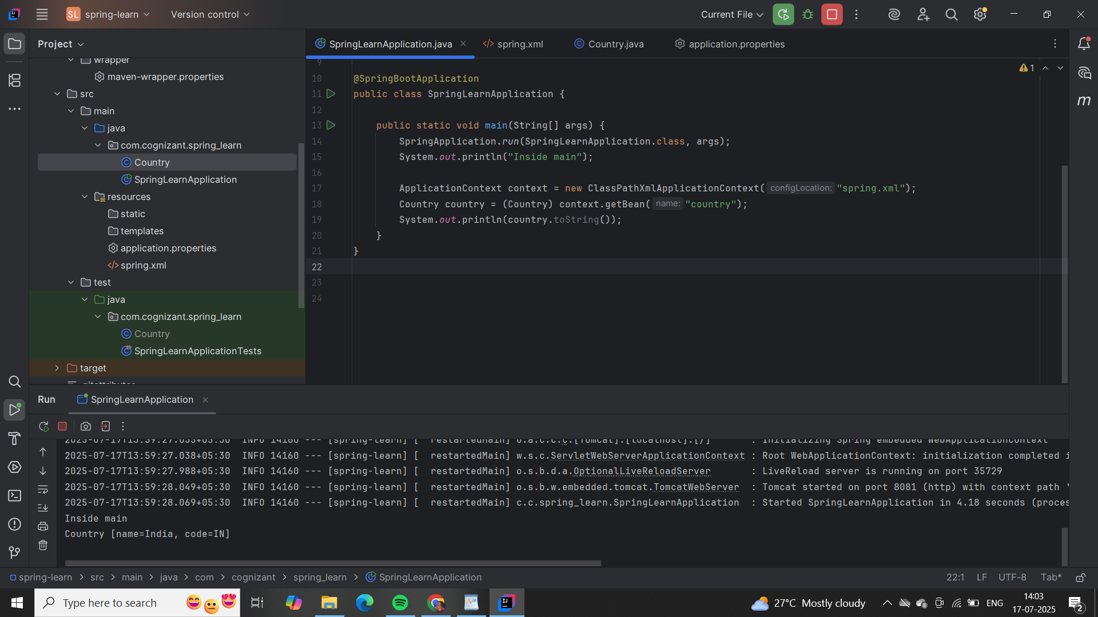

**Hands on 1**

**Spring Core – Load Country from Spring Configuration XML**

An airlines website is going to support booking on four countries. There will be a drop down on the home page of this website to select the respective country. It is also important to store the two-character ISO code of each country.

Code Name

US United States

DE Germany

IN India

JP Japan

Above data has to be stored in spring configuration file. Write a program to read this configuration file and display the details.

Steps to implement

Pick any one of your choice country to configure in Spring XML configuration named country.xml.

Create a bean tag in spring configuration for country and set the property and values

<bean id="country" class="com.cognizant.springlearn.Country">

<property name="code" value="IN" />

<property name="name" value="India" />

</bean>

Create Country class with following aspects:

Instance variables for code and name

Implement empty parameter constructor with inclusion of debug log within the constructor with log message as “Inside Country Constructor.”

Generate getters and setters with inclusion of debug with relevant message within each setter and getter method.

Generate toString() method

Create a method displayCountry() in SpringLearnApplication.java, which will read the country bean from spring configuration file and display the country details. ClassPathXmlApplicationContext, ApplicationContext and context.getBean(“beanId”, Country.class). Refer sample code for displayCountry() method below.

ApplicationContext context = new ClassPathXmlApplicationContext("country.xml");

Country country = (Country) context.getBean("country", Country.class);

LOGGER.debug("Country : {}", country.toString());

Invoke displayCountry() method in main() method of SpringLearnApplication.java.

Execute main() method and check the logs to find out which constructors and methods were invoked.

SME to provide more detailing about the following aspects:

bean tag, id attribute, class attribute, property tag, name attribute, value attribute

ApplicationContext, ClassPathXmlApplicationContext

What exactly happens when context.getBean() is invoked.

**Answer:**

**country.xml**

<?xml version="1.0" encoding="UTF-8"?>

<beans xmlns="http://www.springframework.org/schema/beans"

xmlns:xsi="http://www.w3.org/2001/XMLSchema-instance"

xsi:schemaLocation="http://www.springframework.org/schema/beans

http://www.springframework.org/schema/beans/spring-beans.xsd">

<bean id="country" class="com.cognizant.springlearn.Country">

<property name="code" value="IN" />

<property name="name" value="India" />

</bean>

</beans>

**Country.java**

package com.cognizant.springlearn;

import org.slf4j.Logger;

import org.slf4j.LoggerFactory;

public class Country {

private static final Logger LOGGER = LoggerFactory.getLogger(Country.class);

private String code;

private String name;

public Country() {

LOGGER.debug("Inside Country Constructor.");

}

public String getCode() {

LOGGER.debug("Inside getCode()");

return code;

}

public void setCode(String code) {

LOGGER.debug("Inside setCode()");

this.code = code;

}

public String getName() {

LOGGER.debug("Inside getName()");

return name;

}

public void setName(String name) {

LOGGER.debug("Inside setName()");

this.name = name;

}

@Override

public String toString() {

return "Country{" +

"code='" + code + '\'' +

", name='" + name + '\'' +

'}';

}

}

**SpringLearnApplication.java**

package com.cognizant.springlearn;

import org.slf4j.Logger;

import org.slf4j.LoggerFactory;

import org.springframework.context.ApplicationContext;

import org.springframework.context.support.ClassPathXmlApplicationContext;

public class SpringLearnApplication {

private static final Logger LOGGER = LoggerFactory.getLogger(SpringLearnApplication.class);

public static void main(String[] args) {

LOGGER.info("START");

displayCountry();

LOGGER.info("END");

}

public static void displayCountry() {

ApplicationContext context = new ClassPathXmlApplicationContext("country.xml");

Country country = context.getBean("country", Country.class);

LOGGER.debug("Country : {}", country.toString());

}

}

**pom.xml**

<?xml version="1.0" encoding="UTF-8"?>

<project xmlns="http://maven.apache.org/POM/4.0.0"

xmlns:xsi="http://www.w3.org/2001/XMLSchema-instance"

xsi:schemaLocation="http://maven.apache.org/POM/4.0.0

http://maven.apache.org/xsd/maven-4.0.0.xsd">

<modelVersion>4.0.0</modelVersion>

<groupId>com.cognizant</groupId>

<artifactId>spring-learn</artifactId>

<version>0.0.1-SNAPSHOT</version>

<packaging>jar</packaging>

<name>spring-learn</name>

<description>Spring Learn Project</description>

<properties>

<java.version>17</java.version>

</properties>

<dependencies>

<!-- Spring Core & Context -->

<dependency>

<groupId>org.springframework</groupId>

<artifactId>spring-context</artifactId>

<version>5.3.36</version>

</dependency>

<!-- SLF4J Logger -->

<dependency>

<groupId>org.slf4j</groupId>

<artifactId>slf4j-api</artifactId>

<version>2.0.13</version>

</dependency>

<!-- SLF4J Simple (for console output) -->

<dependency>

<groupId>org.slf4j</groupId>

<artifactId>slf4j-simple</artifactId>

<version>2.0.13</version>

</dependency>

</dependencies>

<build>

<plugins>

<!-- Compiler Plugin -->

<plugin>

<groupId>org.apache.maven.plugins</groupId>

<artifactId>maven-compiler-plugin</artifactId>

<version>3.11.0</version>

<configuration>

<source>${java.version}</source>

<target>${java.version}</target>

</configuration>

</plugin>

</plugins>

</build>

</project>

**Output:**



